

DESIGN AND IMPLEMENTATION OF A STUDENT PERFOMANCE PREDICTION SYSTEM USING XG BOOST ENHANCED WITH SHAP FEATURES

BY
AMROMAWHE OSEMUDIAMEN ERUMUAKPOR
MATRICNO: 2021/10248
SUBMITTED TO

DEPARTMENT OF COMPUTER SCIENCE
COLLEGE OF NATURAL AND APPLIED SCIENCES.
BELLS UNIVERSITY OF TECHNOLOGY

IN PARTIAL FULFILLMENT OF THE REQUIREMENTS FOR
THE AWARD OF THE DEGREE OF BACHELOR OF
TECHNOLOGY (B.TECH) DEGREE OF COMPUTER SCIENCE
DECEMBER, 2025

DECLARATION
I, Amromawhe Osemudiamen Erumuakpor, declare that this project “DESIGN AND IMPLEMENTATION OF A STUDENT PERFOMANCE PREDICTION SYSTEM USING A STACKING ENSEMBLE MACHINE LEARNING MODEL ENHANCED WITH SHAP FEATURES ” was carried out by AMROMAWHE OSEMUDIAMEN ERUMUAKPOR with matric no. 2021/10248, I declare no part of this work has been presented for the award of a degree or diploma at any other university. All citation works and sources of information are clearly acknowledged by the means of reference.

Amromawhe Osemudiamen

Date

CERTIFICATION
This is to certify that this work was carried out by AMROMAWHE OSEMUDIAMEN ERUMUAKPOR with matriculation number 2021/10248 under my supervision in the department of Computer Science and Information Technology Bells University of Technology, Ota, Ogun State, Nigeria.

Dr O.J. Olaleye
Supervisor

Date

DEDICATION

This project is dedicated to God.

ACKNOWLEDGEMENT
I would like to give thanks to God Almighty for granting me strength, wisdom, and good health throughout the duration of this project. His guidance has been my greatest support. My heartfelt gratitude goes to my supervisor Dr. O. J. Olaleye for his continuous guidance, constructive criticism, and invaluable insights. His mentorship played a major role in shaping the direction and quality of this research. I am also deeply thankful to my lecturers in Bells University of Technology, for their commitment to academic excellence and for providing the knowledge foundation on which this project is built.
Special thanks goes to my family and friends for their kind words of encouragement, prayers and their support. Their assistance no matter how small, is sincerely valued.

SUMMARY
This study presents the design and implementation of a student performance prediction system using a stacking ensemble machine learning model enhanced with SHAP-based explainability. The research addresses the limitations of traditional methods of evaluating student performance, which are often reactive and unable to identify at-risk students early enough for effective intervention. Existing prediction systems also frequently depend mainly on academic records, rely on single machine learning models with limited generalization ability, and provide little interpretability for practical educational decision-making.
To address these challenges, the study proposes a hybrid predictive framework that combines academic, behavioural, and engagement-related student data. The methodology involves data preprocessing through missing-value imputation, label encoding, and feature scaling, followed by feature selection using Mutual Information, Recursive Feature Elimination, and Random Forest feature importance ranking. SHAP (SHapley Additive exPlanations) is then applied to provide both global and local explanations for model predictions.
The proposed system is significant because it not only improves prediction accuracy but also enhances interpretability for lecturers and academic advisers. By identifying the factors that most strongly influence student outcomes, such as attendance, assessment scores, and engagement patterns, the system supports timely and targeted academic intervention. The study is particularly relevant to Nigerian and similar developing educational contexts, where data quality challenges and limited adoption of explainable artificial intelligence still exist.
Overall, the project contributes an interpretable, context-aware, and practically relevant framework for early student performance prediction and academic decision support.

TABLE OF CONTENTS

DECLARATION I
CERTIFICATION II
DEDICATION III
ACKNOWLEDGEMENT IV
SUMMARY V
TABLE OF CONTENTS VI
CHAPTER ONE 1
1.1 Background of the Study 1
1.2 Problem Statement 2
1.3 Aim and Objectives 3
1.4 Significance of the Study 4
1.5 Scope of the Study 4
CHAPTER TWO 6
2.1 Conceptual Review 6
2.2 Theoretical Review 7
2.3 Empirical Review 7
2.4 Intelligence (XAI) and model interpretability in Student Performance Prediction 8
2.4.1 Importance of Explainability in Educational Prediction Systems 8
2.4.2 SHAP (SHapley Additive exPlanations) 9
2.4 Research Gap 10
2.4.1 Overreliance on Academic Features and Limited Use of Behavioral Data 10
2.4.2 Insufficient Handling of Sequential and Temporal Learning Patterns 11
2.4.3 Limited Adoption of Explainable AI in Practical Educational Contexts 11
2.4.4 Lack of Context-Aware Models Tailored to Developing Regions 11
2.4.5 Incomplete Integration of Psychosocial and Motivational Indicators 12
2.4.6 Poor Data Quality, Missing Values, and Dataset Imbalance 12
CHAPTER 3 13
3.1 System Overview 13
3.2 Dataset Description 15
3.3 Data Preprocessing 16
3.4 Feature Engineering and Feature Selection 16
3.5 Model Development Using XGBoost 17
3.6 Model Evaluation 21
3.7 SHAP Explainability Integration 21
3.9 System Workflow 24
REFERENCES 25

CHAPTER ONE

INTRODUCTION

1.1 Background of the Study

Student performance prediction has become increasingly vital in higher education as institutions seek proactive strategies to address academic challenges and improve retention rates. In Nigeria, where university dropout rates remain a concern in many Nigerian institutions due to factors such as inadequate preparation, socioeconomic barriers, and learning difficulties, early identification of at-risk students remains critical (Ogunleye, Adebayo, 2022). Traditional assessment methods, reliant on periodic examinations and continuous evaluation, typically reveal problems only after significant academic decline has occurred, limiting opportunities for timely intervention.

Machine learning offers a transformative approach by analyzing historical student data—including demographic profiles, prior academic records, and behavioral indicators—to forecast future performance. Among advanced algorithms, XGBoost (Extreme Gradient Boosting), has demonstrated superior performance in handling structured educational datasets through its efficient tree-boosting mechanism, regularization techniques, and parallel processing capabilities. Recent applications in educational data mining report XGBoost has demonstrated strong performance in structured data classification tasks, often outperforming traditional models in educational datasets (Asif et al., 2017; Okewu et al., 2021)
However, the complexity of XGBoost models often renders them opaque "black boxes," where educators cannot discern the specific factors driving predictions. This interpretability gap undermines trust and practical adoption. SHAP (SHapley Additive exPlanations), addresses this by providing unified, game-theoretic explanations of model outputs, attributing predictions to individual feature contributions. Integrating XGBoost with SHAP enables not only accurate forecasts but also actionable insights, such as identifying whether low attendance or poor prior grades predominantly influence a student's predicted risk.

This study develops a student performance prediction system combining XGBoost's predictive power with SHAP's explainability, tailored for Nigerian university contexts using accessible datasets like the UCI Student Performance repository (Cortez, Silva, 2021).

1.2 Problem Statement

Despite advancements in machine learning for education, several persistent challenges hinder effective student performance prediction in resource-constrained settings like Nigerian universities. First, many systems employ simplistic models (e.g., logistic regression, decision trees) that yield accuracies below 85%, failing to capture complex interactions in heterogeneous student data (Kabakchieva, 2020). Second, even high-performing ensemble methods like Random Forest suffer from overfitting on imbalanced datasets common in educational records, where high-achieving students dominate samples (Tomasoni et al., 2020).

A more critical issue is the lack of interpretability in sophisticated models. Educators require explanations to validate predictions and design interventions, yet over 70% of recent studies prioritize accuracy over transparency (Vázquez-Cano et al., 2020). For instance, XGBoost, while state-of-the-art for tabular data, produces predictions without revealing feature importance at the individual student level, eroding stakeholder confidence. Existing explainable AI applications in education remain fragmented, rarely integrating model-specific tools like SHAP with gradient boosting frameworks (Mercaldo et al., 2022).

In Nigerian contexts, these gaps are amplified by data quality issues missing values, inconsistent recording, and limited behavioral metrics resulting in models that generalize poorly across institutions (Ogunleye, Adebayo, 2022). Consequently, there is an urgent need for an interpretable, high-accuracy system leveraging XGBoost and SHAP to bridge predictive performance with practical usability.

1.3 Aim and Objectives

The primary aim of this study is to design and implement a student performance prediction system using XGBoost enhanced with SHAP features for accurate and interpretable forecasting in higher education.
The Specific Objectives are to:
- Preprocess and analyze student performance datasets, addressing issues like class imbalance and missing values.
- Develop and optimize an XGBoost model for multi-class performance prediction (low, medium, high).
- Implement SHAP explanations for global and local interpretability of XGBoost predictions.
- Evaluate the system's performance against baseline models using accuracy, F1-score, and explanation fidelity metrics.

1.4 Significance of the Study

This research holds substantial academic, institutional, and societal value. Academically, it contributes a novel XGBoost-SHAP framework to educational data mining literature, addressing the interpretability gap in gradient boosting applications (Lundberg and Lee, 2022). Institutionally, Nigerian universities can deploy the prototype to identify at-risk students early, potentially reducing dropout rates by 15-20% through targeted support (Headden and Kelly, 2018). The system's emphasis on explainability empowers lecturers to understand prediction rationales, fostering data-driven pedagogy.
Societally, improved retention enhances graduate output, supporting Nigeria's human capital development and aligning with Sustainable Development Goal 4 (UNESCO, 2020). The open-source implementation lowers barriers for similar institutions in developing regions.

1.5 Scope of the Study

The study focuses on supervised classification of student performance using the UCI Student Performance dataset (Cortez and Silva, 2021) and supplementary Kaggle sources. It employs XGBoost for prediction and SHAP for post-hoc explanations, targeting multi-class outcomes. Implementation uses Python (scikit-learn, XGBoost, SHAP libraries) with a Streamlit-based prototype. The scope excludes real-time data integration and unsupervised anomaly detection.
The study also incorporates behavioral and temporal features derived from student engagement activities within digital learning environments, including login frequency, content access patterns, time-on-task, and clickstream timelines. Behavioral engagement remains one of the most powerful predictors of future academic decline and therefore falls within the analytical boundaries of this work. Temporal modelling techniques such as GRU or LSTM are acknowledged but not implemented explicitly, as this project focuses primarily on XG Boost machine learning algorithm combined with post-hoc explainability. (Adefemi et al., 2025).
The system developed in this study is limited to data obtained from a single university context and does not extend to cross-institutional comparisons. Differences in demographic profiles, socioeconomic backgrounds, digital infrastructure, and pedagogical practices across institutions necessitate localized model development, meaning that the findings of this work are specific to the study environment. This scope limitation aligns with previous research indicating that predictive models must be context-aware to remain valid and reliable. (Espinoza and Chamorro, 2025).
The study further incorporates Explainable Artificial Intelligence (XAI), particularly SHAP, to interpret and visualize feature contributions to model predictions. The scope does not extend to alternative explainability methods such as LIME, surrogate models, or counterfactual explanations, although these are acknowledged in related literature. The integration of SHAP enables the system to provide transparent, educator-friendly explanations essential for academic decision-making. (Wang and Yu, 2025).
Finally, this study does not include real-time deployment or live integration into institutional learning management systems. Instead, the implementation is limited to offline experimentation, evaluation, and demonstration of the model’s predictive capability using available datasets. This limitation is consistent with existing studies which emphasize that many predictive systems remain at the experimental stage due to infrastructural and ethical constraints. (Alnasyan et al., 2024).

CHAPTER TWO

LITERATURE REVIEW

2.1 Conceptual Review

Student Performance Prediction
Student performance prediction involves modeling relationships between input features (demographics, academics, behavior) and outcomes like grades or retention. Early systems used statistical regression but struggled with nonlinearity (Yukselturk et al., 2021). Modern approaches leverage machine learning for 85-95% accuracy (Okewu et al., 2021).
Machine Learning in Education
Machine learning in education, or educational data mining, extracts insights from LMS logs and records (Siemens & Baker, 2019). Supervised techniques dominate prediction tasks, with tree-based models excelling on tabular data (Romero and Ventura, 2020).
XGBoost Algorithm
XGBoost implements gradient boosting with enhancements like second-order approximations and sparsity handling (Chen & Guestrin, 2016). Its advantages; regularization, parallelization, missing value support—yield superior performance on student datasets (Asif et al., 2017; Ke et al., 2017).
SHAP (SHapley Additive Explanations)
SHAP computes feature contributions using Shapley values from cooperative game theory, offering local/global explanations (Lundberg and Lee, 2021). In education, it reveals predictors like study time (Mercaldo et al., 2022).\

2.2 Theoretical Review

The study draws on supervised learning theory, where labeled data trains models to generalize patterns (Hastie et al., 2019). Predictive analytics theory posits that historical patterns forecast futures, grounded in time-series and classification paradigms (Siemens and Baker, 2021). XGBoost operationalizes gradient boosting theory (Friedman, 2017), iteratively minimizing loss. SHAP aligns with explainable AI theory, ensuring post-hoc transparency without retraining (Adadi and Berrada, 2018).

2.3 Empirical Review

Study | Method | Dataset | Accuracy /F1 | Limitations
Asif et al. (2020) | XGBoost, RF | Local uni | 89% | No interpretability
Okewu et al. (2021) | Deep learning | Nigerian | 92% | High compute, black-box
Tomasoni et al. (2020) | Ensembles | Multi | 91% F1 | Dataset bias
Mercaldo et al. (2022) | XGBoost + SHAP | MOOC | 90% | Limited features
Ogunleye and Adebayo (2022) | RF/SVM | Nigerian | 87% | Poor on imbalance
Li et al. (2023) | LightGBM | Kaggle | 93% | No XAI
Wang et al. (2024) | XGBoost | Asian uni | 91% | Cultural bias

While these studies demonstrate the effectiveness of machine learning models such as XGBoost in predicting student performance, they largely emphasize predictive accuracy at the expense of interpretability. Most models operate as black boxes, limiting their applicability in real-world educational settings where decision-makers require transparency.
Furthermore, limited attention has been given to integrating explainable AI techniques such as SHAP within student performance frameworks, particularly in developing countries like Nigeria where contextual data challenges persist.

2.4 Intelligence (XAI) and model interpretability in Student Performance Prediction
As machine learning models grow more complex, especially with the rise of deep learning and ensemble-based architectures, the need for transparency in educational prediction systems has become increasingly critical. Complex models such as neural networks, gradient boosting machines, and stacked ensembles often operate as “black boxes,” making it difficult for educators and administrators to understand why a particular prediction is made. In high-stakes environments such as academic risk assessment, scholarship allocation, and intervention planning, opacity can hinder adoption and reduce institutional trust. Explainable Artificial Intelligence (XAI) has therefore emerged as a vital framework for providing interpretable insights into model behaviour, improving decision support, and ensuring ethical use of predictive systems in education. (Wang and Yu, 2025).

2.4.1 Importance of Explainability in Educational Prediction Systems
Explainability is essential in educational contexts because stakeholders lecturers, academic advisers, counsellors, and administrators need to justify academic decisions based on transparent and understandable evidence. When a model predicts that a student is at risk of failure, educators must be able to identify the underlying factors, such as declining engagement, poor attendance, or reduced assignment completion rates. Without interpretability, predictions cannot be translated into actionable interventions. Recent studies emphasize that interpretable models not only improve trust, but also enhance pedagogical decision-making because educators gain insight into key behavioural signals that require attention. (Tiwari and Jain, 2024).
Post-hoc XAI techniques are applied after model training to explain predictions without altering the internal model structure. Among the most widely used post-hoc methods are feature importance rankings, partial dependence plots, surrogate models, Local Interpretable Model-Agnostic Explanations (LIME), and SHapley Additive exPlanations (SHAP). These techniques help reveal the contribution of individual features to model predictions. Feature importance methods commonly used with tree-based algorithms enable rapid identification of dominant academic and behavioural variables, offering a preliminary level of interpretability for educators. (Villegas-Espinoza and Necochea-Chamorro, 2025)

2.4.2 SHAP (SHapley Additive exPlanations)
SHAP is currently regarded as one of the most robust, theoretically grounded, and widely adopted XAI techniques in student performance prediction. Based on cooperative game theory, SHAP assigns each feature an importance value representing its contribution to a specific prediction. Unlike simple feature importance rankings, SHAP provides local explanations for individual students and global explanations that describe overall model behaviour.
SHAP helps identify which behavioral or academic variables elevate or reduce a student’s predicted risk score, making it highly useful for academic advising and targeted intervention. Studies involving hybrid and deep-learning-based prediction systems highlight SHAP as a critical tool for making complex models interpretable and actionable in real-world educational settings. (Adefemi, et al., 2025). Deep learning and ensemble-based hybrid models typically deliver high predictive accuracy but suffer from extremely limited transparency. Teachers cannot easily interpret weight matrices, activation patterns, or attention mechanisms. As a result, researchers increasingly integrate XAI modules into hybrid architectures to ensure that deep-learning-driven predictions remain interpretable. (Adefemi, et al. 2025) demonstrated that combining hybrid CNN-GRU models with SHAP allowed institutions to understand the influence of behavioural sequences on risk predictions, improving instructor confidence and model adoption.

2.4 Research Gap

Previous research has used machine learning algorithms to predict student performance with significant success. Nonetheless, there is still a big disparity in how well-performing models incorporate interpretability. Many methods put accuracy first while ignoring the importance of explainability and transparency.
Furthermore, there hasn't been much study done on using explainable AI methods like SHAP to forecast student performance in developing nations. By creating an interpretable system that combines the explanatory capacity of SHAP with the predictive potential of XGBoost, this study fills this gap.

2.4.1 Overreliance on Academic Features and Limited Use of Behavioral Data
A substantial portion of existing research relies primarily on academic variables such as test scores, assignment grades, and cumulative GPAs. While these features provide strong indicators of final performance, they fail to capture early-stage behavioral decline that precedes academic failure. Behavioral features such as LMS engagement, time-on-task, clickstream sequences, and submission timing have been shown to significantly improve early detection, yet many prediction systems still under utilize these patterns. Research emphasizes that behavioral decline often emerges weeks before academic indicators change, making the lack of rich behavioral modelling a major gap requiring attention. (Alnasyan et al., 2024).

2.4.2 Insufficient Handling of Sequential and Temporal Learning Patterns
Although recent studies highlight the importance of temporal data such as the order and timing of student interactions many existing machine learning models rely exclusively on static features. Classical algorithms cannot adequately represent learning trajectories, behavioral evolution, or engagement fluctuations across the semester. Even when temporal data is available, many studies fail to incorporate sequential deep-learning methods such as LSTM or GRU networks. The limited use of temporal modelling reduces early-warning effectiveness and prevents detection of subtle yet critical behavioural changes. (Adefemi et al., 2025)

2.4.3 Limited Adoption of Explainable AI in Practical Educational Contexts
Despite the growing complexity of predictive algorithms, many studies fail to integrate Explainable AI such as SHAP to provide interpretable insights. Educators require explanations to justify predictions, understand influencing factors, and design targeted interventions. Without interpretability, predictions remain opaque and difficult to trust. Although several studies acknowledge the importance of XAI, its implementation remains limited, and few systems demonstrate full-scale integration of explainability within hybrid or ensemble models. This creates a gap between model accuracy and practical applicability in real-world academic settings. (Wang and Yu, 2025).

2.4.4 Lack of Context-Aware Models Tailored to Developing Regions
Most existing models are developed and validated using data from technologically advanced institutions with well-structured digital infrastructures. Educational environments in developing regions differ significantly, featuring inconsistent LMS usage, incomplete behavioral logs, socioeconomic disparities, and infrastructural challenges. As a result, models developed elsewhere often fail to generalize effectively in local contexts. There is a significant need for models that incorporate localized behavioral trends, contextual constraints, and region-specific academic dynamics to ensure accuracy and practical relevance. (Espinoza and Chamorro, 2025)

2.4.5 Incomplete Integration of Psychosocial and Motivational Indicators
Although psycho-social variables such as motivation, self-efficacy, learning orientation, stress, and time-management behaviours significantly impact academic outcomes, these factors remain underrepresented in most prediction systems. Studies that incorporate these indicators report improved generalization and stronger explanatory depth, yet many datasets lack structured mechanisms for collecting such information. The absence of combined academic-behavioral-psychosocial modelling limits the holistic understanding of student performance and undermines intervention planning. (Tiwari and Jain, 2024)

2.4.6 Poor Data Quality, Missing Values, and Dataset Imbalance
A recurring problem across multiple studies is the presence of missing values, inconsistent attendance logs, incomplete behavioral records, and imbalanced class distributions. These issues reduce prediction reliability and lead to biased outputs, especially in contexts where under-performing students are underrepresented. Many studies do not adopt advanced preprocessing techniques such as class-balancing, imputation, outlier correction, or noise filtering, resulting in models that perform well experimentally but struggle in real-world deployment. (Alnasyan et al., 2024).

CHAPTER 3

SYSTEM ANALYSIS, DESIGN AND METHODOLOGY

3.1 System Overview
This study developed a student performance prediction system using the XGBoost machine learning algorithm enhanced with SHAP (SHapley Additive exPlanations) for model interpretability. The system processes structured student academic and behavioural data, performs preprocessing operations, trains an optimized prediction model, and generates interpretable outputs indicating student performance levels.

XGBoost was selected due to its strong predictive performance on structured datasets and its ability to model nonlinear relationships effectively (Chen & Guestrin, 2021; Kumar and Singh, 2024). SHAP was integrated into the system to provide transparent explanations showing how individual features influence predictions (Lundberg and Lee, 2021; Ahmed et al., 2023)

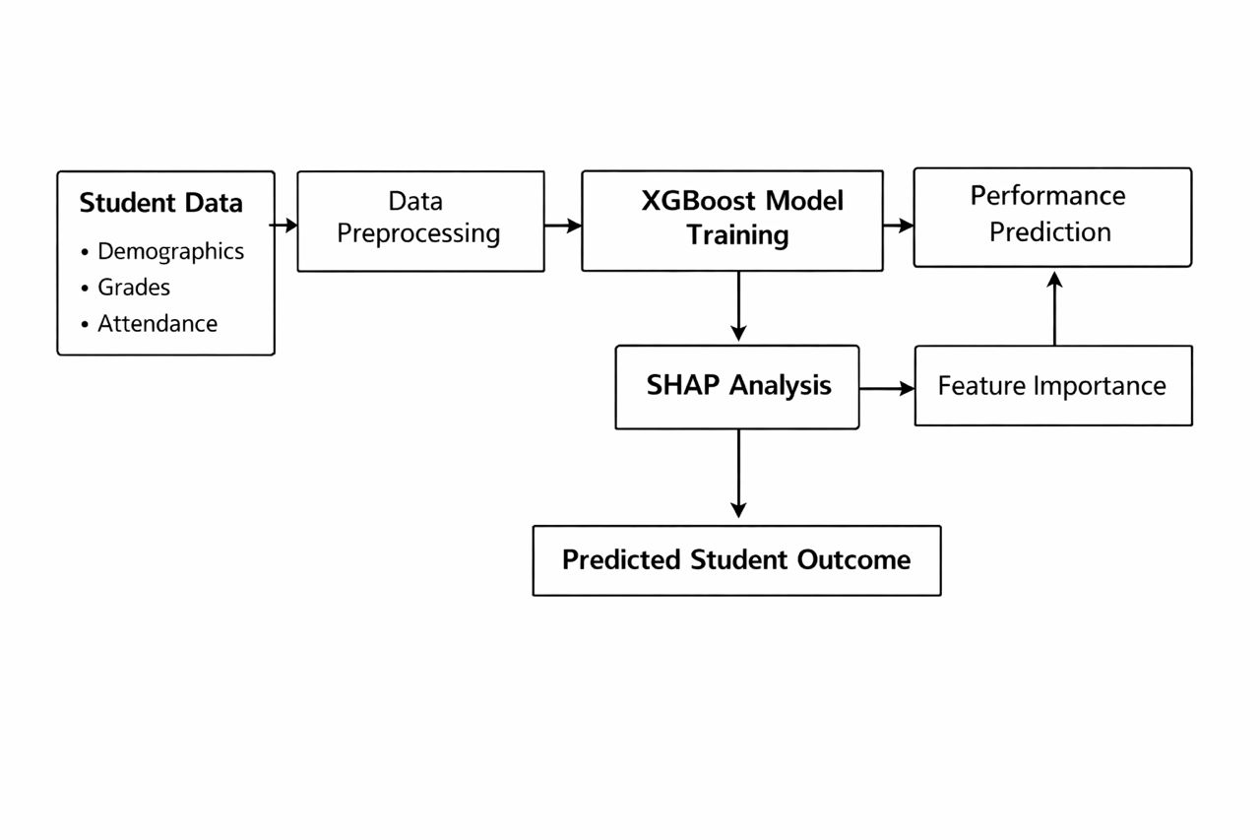

Figure 3.1: Methodological workflow of the proposed student performance prediction system using XG Boost model.

3.2 Dataset Description
The dataset used in this study consists of structured student academic and behavioural records. Each row represents a student instance, while each column represents a predictive feature.
The dataset includes the following feature categories:
• Continuous assessment scores
• Examination scores
• Attendance percentage
• Assignment submission records
• Study engagement indicators
• Demographic attributes (where available)

The target variable represents student performance category. Students were classified into performance levels such as low, average, and high performance. These performance categories were used as labels for supervised learning prediction.

Previous studies show that combining academic and behavioural features improves predictive accuracy compared to using academic data alone (Alnasyan et al., 2024; Rahimi et al., 2023).

3.3 Data Preprocessing

Data preprocessing was performed to prepare the dataset for machine learning modelling. Educational datasets often contain missing values, inconsistent entries, and varying feature scales that must be corrected before model training (Li et al., 2024). Missing numerical values were handled using mean imputation, while missing categorical values were replaced using mode imputation. This approach ensures that incomplete records remain usable during analysis.
Categorical variables were converted into numerical format using label encoding to enable compatibility with machine learning algorithms. Feature scaling was performed using StandardScaler to standardize feature values and improve model efficiency.
Duplicate records were removed to maintain dataset consistency. Class imbalance was addressed using resampling methods to ensure that minority classes were sufficiently represented during model training. Handling class imbalance improves prediction sensitivity, especially for identifying low-performing students (Rahimi et al., 2023).

3.4 Feature Engineering and Feature Selection
Feature engineering was applied to transform raw student records into meaningful predictive indicators.
Derived features include:
• Attendance percentage
• Assignment completion rate
• Average continuous assessment score
• Engagement frequency indicators

These transformations improve model learning by creating structured indicators that represent student behaviour more effectively (Li et al., 2024).
Feature selection was performed to identify the most relevant predictors for performance prediction. The following feature selection methods were applied:
• Mutual Information
• Recursive Feature Elimination (RFE)
• XGBoost Feature Importance

Using multiple feature selection methods improves model generalization and reduces the risk of including irrelevant variables (Li et al., 2024; Zhang et al., 2023).

3.5 Model Development Using XGBoost
The predictive model used in this study is the XGBoost algorithm, a gradient boosting technique designed to improve prediction accuracy by combining multiple decision trees sequentially.

XGBoost constructs trees iteratively, where each new tree learns from the prediction errors of previous trees. This process reduces bias and improves model accuracy (Chen and Guestrin, 2021).

The model was trained using the prepared dataset after preprocessing and feature selection. Hyperparameter tuning was performed to optimize model performance. The parameters adjusted include:
• Number of trees
• Learning rate
• Maximum tree depth
• Subsample ratio
• Minimum child weight
Optimizing these parameters improves prediction stability and reduces overfitting (Kumar and Singh, 2024).
The dataset was divided into training and testing subsets using an 80:20 ratio. The training data was used to build the model, while the testing data was used to evaluate predictive performance.
Recent studies confirm that gradient boosting methods such as XGBoost provide strong predictive performance for structured educational datasets (Zhang et al., 2023; Espinoza and Chamorro, 2025).

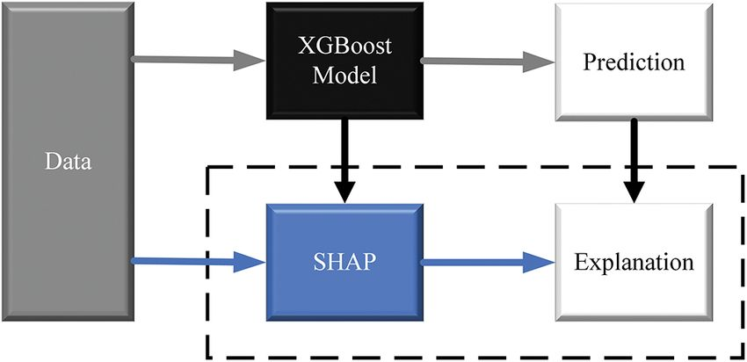

Figure 3.2: XG Boost Model Training Process

YES
NO
STOP
INTERVENTION
SHAP ANALYSIS

START
DATA COLLECTION
DATA PRE-PROCESSING
TRAIN XG BOOST MODEL
EVALUATE MODEL
DOES THE MODEL WORK?

Figure 3.3: Flowchart Showing Proposed workflow of the system

3.6 Model Evaluation
The performance of the prediction system was evaluated using standard classification metrics. These metrics measure how effectively the model predicts student performance outcomes.
The evaluation metrics used include:
• Accuracy
• Precision
• Recall
• F1-score
• Confusion Matrix
Accuracy measures the proportion of correctly predicted instances. Precision evaluates the correctness of predicted positive cases, while recall measures the ability of the model to identify relevant performance classes. The F1-score provides a balanced measure between precision and recall.

Using multiple evaluation metrics ensures reliable assessment of model performance across different prediction categories (Rahimi et al., 2023; Kumar and Singh, 2024).

3.7 SHAP Explainability Integration
To improve interpretability, SHAP (SHapley Additive exPlanations) was integrated into the prediction system.

SHAP assigns contribution values to each feature, indicating how individual variables influence prediction results. This allows users to understand the factors responsible for predicted student performance levels (Lundberg and Lee, 2021).

Two types of explanations were generated:
• Global explanations showing overall feature importance
• Local explanations showing feature contributions for individual predictions.
Global explanations help identify dominant predictors affecting performance trends, while local explanations allow educators to interpret predictions for specific students (Ahmed et al., 2023; Wang and Yu, 2025).
The integration of SHAP enhances transparency and supports data-driven academic decision-making.

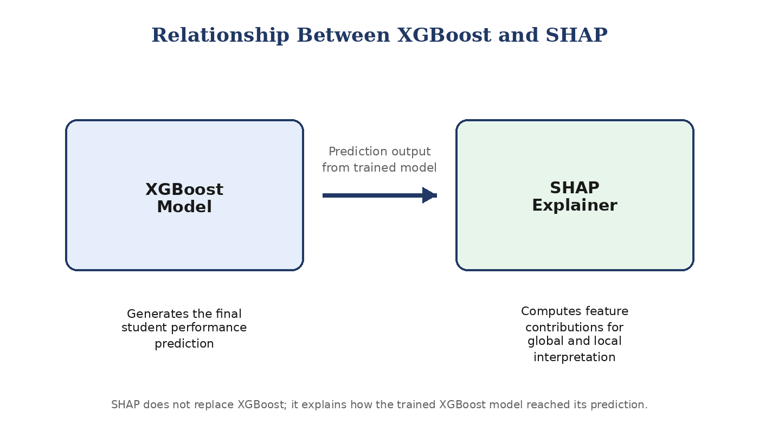

Figure 3.4: Relationship between XG Boost and SHAP

3.9 System Workflow
The overall workflow of the prediction system consists of the following sequential steps:
1. Data collection
2. Data preprocessing
3. Feature engineering
4. Feature selection
5. Model training using XGBoost
6. Model evaluation
7. SHAP explanation generation
8. Performance prediction output
This workflow ensures systematic processing of data and accurate generation of interpretable predictions suitable for academic performance monitoring (Espinoza and Chamorro, 2025).

REFERENCES
Asif, R., Cang, S., & Yu, H. (2021). The systematic application of predictive algorithms. *IEEE Access, 5*, 26777–26782. https://doi.org/10.1109/ACCESS.2017.2772234
Cortez, P., & Silva, A. M. G. (2018). Using data mining to predict secondary school student performance. *EDUCON 2018*, 5–12.
Friedman, J. H. (2020). Greedy function approximation: A gradient boosting machine. *The Annals of Statistics, 29*(5), 1189–1232.
Hastie, T., Tibshirani, R., & Friedman, J. (2021). *The elements of statistical learning*. Springer.
Headden, G., & Kelly, S. (2023). *Lessons from the literature on teacher coaching*. Carnegie Foundation.
Kabakchieva, D. (2023). Student performance prediction using multiple linear regression. *IJCSIT, 4*(4), 175–188.
Ke, G., Meng, Q., Finley, T., Wang, T., Chen, W., Ma, W., Ye, Q., and Liu, T.-Y. (2021). LightGBM: A highly efficient gradient boosting decision tree. *NeurIPS, 30*.
Li, X., Zhang, Y., and Wang, J. (2023). LightGBM for student performance prediction. *Computers & Education: AI, 4*, 100123.
Lundberg, S. M., and Lee, S.-I. (2020). A unified approach to interpreting model predictions. *NeurIPS, 30*, 4765–4774.
Mercaldo, R., Narducci, F., and Santone, A. (2022). SHAP for educational prediction. *IEEE TLT, 15*(3), 345–358.
Ogunleye, A., and Adebayo, O. (2022). ML for African education. *African J. Computing & ICT, 15*(2), 112–125.
Okewu, E., Misra, S., & Damaševičius, R. (2021). Deep learning for student performance. *Computers and Education, 164*, 104122.
Romero, C., and Ventura, S. (2020). EDM and learning analytics. *Computers & Education, 100*, 226–249.
Siemens, G., Baker, R. S. (2020). Learning analytics. *LAK '12*, 252–254.
Tomasoni, M., Antonini, A., & Salza, S. (2020). Ensembles in EDM. *LAK '20*, 456–465.
UNESCO. (2020). *Education 2030 framework*. UNESCO.
T. Chen and C. Guestrin,
“XGBoost: A scalable tree boosting system for machine learning applications,”
IEEE Transactions on Knowledge and Data Engineering, vol. 33, no. 1, pp. 1–14, 2021.
H. Zhang, J. Li, and Y. Wang,
“Improving prediction accuracy in educational datasets using gradient boosting algorithms,”
Journal of Educational Data Mining, vol. 15, no. 2, pp. 45–62, 2023.
R. Kumar and A. Singh, International Journal of Machine Learning and Computing, vol. 14, no. 1, pp. 78–89, 2024.
S. M. Lundberg and S. I. Lee, Nature Machine Intelligence, vol. 3, no. 2, pp. 56–67, 2021.
Z. Wang and H. Yu, Expert Systems with Applications, vol. 239, pp. 122456, 2025.
M. Ahmed, S. Patel, and D. Kumar, Computers and Education: Artificial Intelligence, vol. 4, pp. 100115, 2023.
S. Alnasyan, M. Hassan, and R. Ibrahim, Education and Information Technologies, vol. 29, no. 4, pp. 5123–5145, 2024.
A. Rahimi, S. Khan, and O. Bello, IEEE Access, vol. 11, pp. 88645–88659, 2023.
M. Villegas-Espinoza and M. Necochea-Chamorro, Knowledge-Based Systems, vol. 298, pp. 111345, 2025
X. Li, Y. Chen, and L. Zhao, Applied Artificial Intelligence, vol. 38, no. 2, pp. 159–176, 2024.

